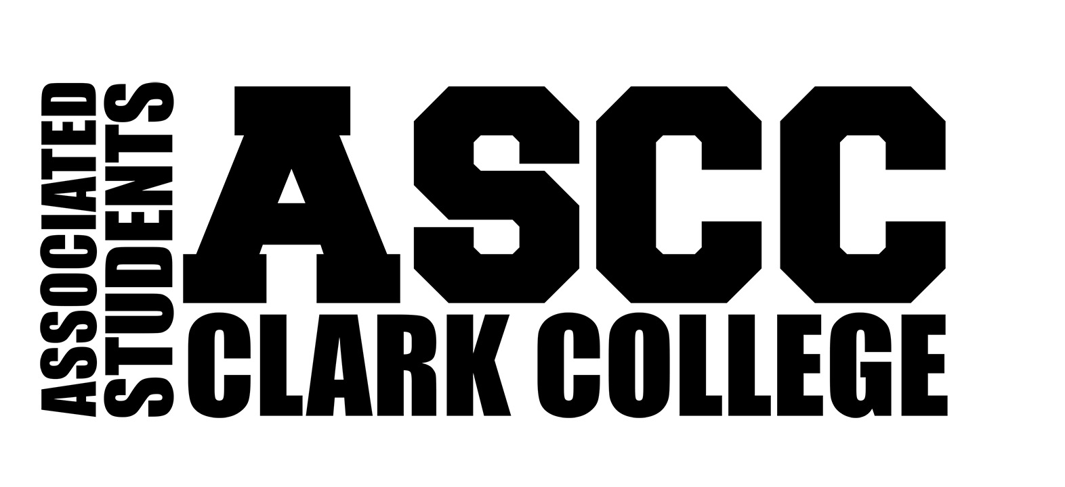

THE HOW TO’S OF

###### BECOMING & BEING AN ASCC CHARTERED CLUB

A quick guide to getting started as an ASCC Student Club

# 

# WHY GET INVOLVED?

## Purpose of Student Clubs

The purpose of a student club is to give students the opportunity to explore interests and combine various aspects of their academic and/or vocational learning into personal action. In a student club, students have the chance to apply their skills and knowledge in a community environment. They work together to set goals, develop plans to achieve those goals, and carry out their plans, while building and maintaining working relationships in the process. In clubs, students learn to apply skills and responsibilities of leadership and to become involved in the campus community.

## Benefits to Students

Students are provided with the opportunity to participate in activities that develop and enhance their abilities.

Student clubs are a means of reaching a diverse pool of students with varied abilities. Clubs provide opportunities to:

* Develop leadership skills involving communication, problem solving, meeting management, decision making, and conflict management.
* Learn to work as part of a team and contribute to group effort.
* Learn to work well with people from diverse backgrounds.
* Enhance self-esteem.
* Meet and become better acquainted with people from the campus and community.
* Apply knowledge and skills learned in the classroom.
* Become better acquainted and more appreciative of instructors and advisors.
* Get more involved in campus and community activities.

# BEING AN OFFICIAL CLUB

## How to Get Started

In order for a student club to become officially recognized by the ASCC, it must submit an ASCC Club Charter Application to the Club Coordinator who will process it for approval. Every club, even returning clubs, need to complete the charter process at the beginning of every Fall quarter. New or returning clubs can charter or re-charter at the beginning of Fall, Winter, or Spring quarter, so long as it is before the annual Spring deadline. (Please reference Club Calendar for all dates and deadlines.) New clubs should also make necessary inquiries to be aware of any possible parallels to existing clubs, student organizations, or College programs/services.

## Charter

A club charter is a document which provides structure for the club’s organization. Club Charter Applications will be provided by the ASCC, and will require you to provide the following information:

* + - 1. Official name of the club.

1. Statement of Purpose for the club
2. Name and signature of the student representative.
3. Name and signature of the advisor.
4. Names, email/phone numbers, and the last 4 digits of the student identification number (SID) of at least ten (10) interested or supportive students. These ten (10) students will be verified by the Club Coordinator before the Club Charter Application can be processed further and brought up for review at Club Committee.

A club charter may be denied or held from approval at any point during the charter process for the following reasons:

* Statement of Purpose is unclear or fails to reflect how the club will benefit the students of Clark College or it fails to state/imply that all students are welcome.
* A similar club or student program already exists to the degree that the potential club could alter membership or financial stability of the existing student organization.
* The College offers a similar/duplicate service for students.
* Necessary charter information is not provided or does not meet guidelines (i.e. missing signatures, does not have ten (10) currently enrolled students interested, risk and liability for desired activity is too great for the participants/College etc.).

**Chartering/Approval Process**

**Step 1: A student interested in starting a club should acquire a Club Charter Application from the Office of Student Life, and contact the Club Coordinator.**

**Step 2: Complete the Club Charter**

1. Select a club name and form a Statement of Purpose. The Statement of Purpose should describe how the club will benefit the students of Clark College, and must be recognizable as open to all students.
2. Seek a Club Advisor. This individual must be a Clark College employee and should preferably be a full-time faculty or staff member. Student Employees (such as Student Government officers or work-study students) are not viable advisors.
3. Provide the potential advisor with a copy of the Letter of Position Acceptance for Club Advisors.
4. Acquire the name, contact information and signature of the Club Advisor on the Club Charter Application. This is their written commitment to serve as the advisor. If the club has more than one advisor, all advisors should receive a copy of the Letter of Position Acceptance and should sign the Club Charter Application.
5. Acquire signatures from ten (10) currently enrolled students who support the club.

**Step 3: The Club Coordinator will review the Club Charter**

* If approved, the Club Coordinator will sign the Club Charter
  + A Club Charter may be denied or held from approval for the reasons listed on page 8. The Club Coordinator will contact the Club Representative to discuss possible revisions needed to the Club Charter.

**Step 4: The Director of Student Life will review the Club Charter**

* If approved by the Club Coordinator, the Director of Student Life will review the Club Charter. If approved, the club is now officially chartered.
* A Club Charter may be denied by the Director of Student Life for the reasons listed above.
  + If denied, the Club Representative will meet with the Director of Student Life. If a satisfactory outcome is not attained, a final appeal may be made to the Dean of Student Success and Retention.

**Step 5: Once approved, the Club Representative or Club Advisor may request a copy of the approved Club Charter. The club is now recognized by the College.**

* The club may now qualify for Club Service Funding, use of facilities and designated areas of the Office of Student Life located in PUB 160.

# 

# Your Rights as a Club

An ASCC club is entitled to:

* The right to use the name of the college or ASCC in connection with the club’s own name.
* Facilities scheduling and use of space on the Clark College campuses.
* Use of the financial services provided by the College.
* The right to conduct fundraising activities and use of the College name and ASCC when off campus.

As a new club you will receive $100 seed money deposited into your club account.

## Your Responsibilities as a Club

You are considered an extension of Clark College and the ASCC and will be expected to conduct your programs and/or activities accordingly. The ASCC Constitution and Bylaws, this Club Handbook, the Student Code of Conduct, and the Clark College Policies and Procedures manual are a few of the documents which define appropriate club conduct.

Chartered student clubs must be open and available to any Clark student regardless of race, color, national origin, sex, age, creed, religion, sexual orientation, gender identity, gender expression, marital status, presence of physical, sensory or mental disability, disabled veteran status, or Vietnam-era veteran status.

## Maintaining Your Status as a Club

In order to be considered an active ASCC club one (1) Club Representative from your club must attend at least three (3) Club Committee meetings per quarter.

* The club representative and officers must be currently registered students.
* The Club Advisor may attend Club Committee meetings in lieu of the representative.
* Each club may only have one (1) Club Representative vote on behalf of that club.
* A representative cannot represent more than one (1) club at a time.
* If a Club Representative or the Club Advisor is unable to attend the weekly meeting, alternate arrangements may be made with the Club Coordinator to ensure meeting requirements are met. It is up to the Club Coordinator’s discretion to allow for meeting make-ups.

Clubs are required to turn in a Club Quarterly Report by the deadline, which is determined by the Club Coordinator, at the end of each quarter. This report will outline general club and club service funding activities that the club participated in or held, progress made within the quarter, club officer names, positions and the number of club members.

Failure to turn in a Club Quarterly Report by the deadline will result in the loss of your club’s charter.

## Club Inactivity

A club is considered inactive if it is represented at less than three (3) Club Committee meetings in any given quarter. Clubs attending less than three (3) meetings will be required to re-charter.

## Club Quarterly Report and Review

The Club Coordinator conducts a quarterly review of all clubs in order to verify club activity and to ensure that the charter is up-to-date. The review includes meeting attendance and the submission of the Club Quarterly Report of club activities.

## Club Member Status

Clubs may have non-students as members, provided the majority of the membership is comprised of currently registered Clark College students. Clubs may not deny membership to any currently registered Clark College student.

Club officers must be currently registered Clark College students. Clubs must ensure, on a quarterly basis, that the officers have student status. The Director of Student Life has the right to review the official status of officers. Clubs may determine additional criteria with regards to officers, provided it is consistent with the basic definition.

Clubs without officers must ensure that individuals who are made responsible for such activities as event planning, finances, travel, etc. are currently registered students.

The voting members of a club must be currently registered students. Clubs may determine additional criteria with regards to voting members, provided it is consistent with the basic criteria.

## Club Advisor Status

The ASCC Executive Council and Office of Student recognize the faculty/staff member(s) who sign the club charter as the official advisor(s) to the club. Club Advisor status may be transferred, shared, granted or removed with use of the “Change of Advisor” form, which can be obtained from the Club Coordinator.

Clubs may have more than one advisor. It is up to the advisors to share information and responsibilities.

Clubs may have individuals who serve as community resources to campus clubs; however these persons may not serve in a Club Advisor capacity; as such, community resources may not make arrangements for use of facilities, sign official paperwork or travel (as the advisor) with the club. Club funds may not be used to pay for any expenses related to the community resource person, with a few exceptions. The Director of Student Life can provide further information on appropriate expenditures with regards to community resources.

# CLUB COORDINATOR AND CLUB COMMITTEE

## Club Coordinator

The ASCC Club Coordinator works to support clubs. It is the responsibility of the Club Coordinator to:

* Be the first point of contact when clubs have questions or need help.
* Serve as chair of the Club Committee.
* Work closely with clubs in planning and coordinating club meetings and events:
* Demonstrate a working knowledge of the procedures for facilities use, custodial, stage setup requests and campus security requirements for all club events.
* Plan and implement the training of student club representatives:
* Coordinate a quarterly event (excluding summer) for club recruitment.
* In coordination with the Director of Student Life:
  + Prepare the Club Service Funding annual budget.
  + Prepare and periodically update the Club Handbook.
  + Mediate conflicts between and within clubs:

The Club Coordinator may be contacted by phone at (360) 992-2353 x3169 or by email at ascccc@clark.edu. The desk of the Club Coordinator is located in The Office of Student Life, Penguin Union Building (PUB) room 160.

## Club Committee

The Club Coordinator uses Club Committee to communicate and share information with Club representatives. Club Committee also acts as a forum for clubs to meet and share their events and activities, promote participation, and exchange other information. Club Committee is also a body from which volunteers for various activities can be solicited.

Club Committee is comprised of one (1) representative from each active club. The Club Coordinator serves as the chair of the committee and the Executive Assistant as recorder of the minutes.

**Why it is Important to Participate in the Meetings?**

The Club Committee is one of the only ways for the clubs to communicate with all other campus clubs. In addition, most of the decisions made by Student Government depend upon student input and approval. The ASCC relies on the Club Committee as a resource for this contribution and support. Club Committee meetings provide the opportunity for club activities and reports to appear in official minutes so they are properly documented. The Club Representative must attend a minimum of three (3) Club Committee meetings per quarter for their club to be considered active by the ASCC.

**Club Committee Representatives**

Representatives are to be appointed by each club. It will be the duty of the Club Representatives to act on behalf of the interests of their club when voting and giving club reports to the Club Committee.

* Representatives must be currently enrolled Clark College students (except when the Club Advisor is acting as representative). There is no GPA requirement.
* One individual may represent no more than one (1) club at any given Club Committee meeting.
  + Club representatives must be members of the club that they are representing in order to take the information discussed at Club Committee back to their individual club meetings.
* The club representative will serve to inform their own club of events and issues as presented in Club Committee. Clubs may alternate club representatives in order to fulfill attendance requirements.

**Please refer to the Club Handbook for further information or contact the Club Coordinator.**